**Sunday 20th December 2015**

**Fourth Sunday of Advent**

S GILES-IN-READING

*sgilesreading.org.uk*

*Rector & Vicar:* Fr David Harris (0118) 9572831 [*sgiles.vicar@gmail.com*](mailto:sgiles.vicar@gmail.com)

*Curate:* Fr Sam McNally-Cross: (0118) 3767583 [*sgiles.curate@gmail.com*](mailto:sgiles.curate@gmail.com)

*Churchwardens:* Sylvia Gooding & Peter Bloomfield

Hymns: ***The English Hymnal***

Mass Setting: *Plainsong*

Motet:

Entrance Hymn: *8*  Offertory Hymn: *553*

Communion Hymns: *518 & 14* Recessional Hymn: *7*

Voluntary:

**OUR INTENTIONS TODAY.**Those in need: Tony Allen, Sarah Alderson, Jean Chapman, Pat Davis, Peter Davis, Peter George, Herbert Hinton, Phyllis Hinton, Maurice Houghton, Grace John, Kate Morl, Diana Sanni, Elizabeth Sayer, Sheena Sixsmith, Margaret Summers, Sophie Thomas, Fr Christopher Walker, Ann Westgarth and Nesta Williams.

The departed: Victor Bloomfield, Ted Bonney, Victor Brant, Mary Butwell, George Godsell, Roderick Gradidge, Eric Hoare, James Richardson, Ted Rowe and Frances Sarney.

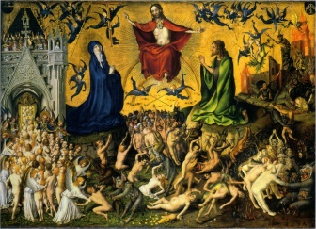

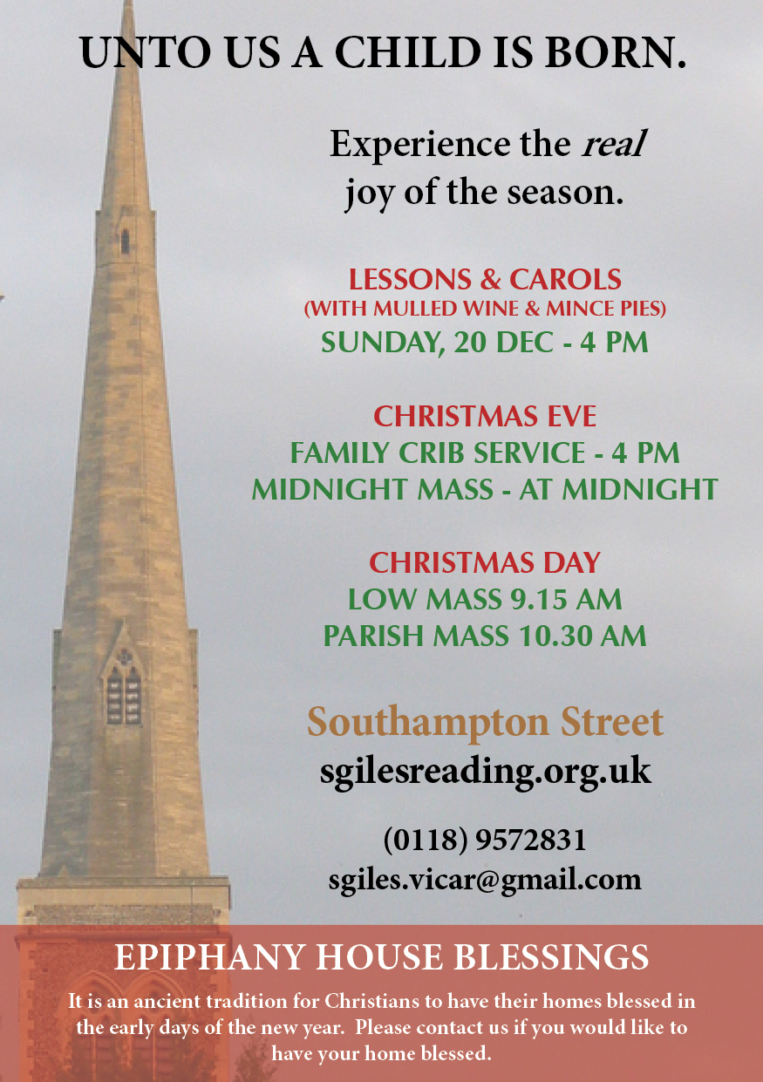

**OUR INTENTIONS TODAY.**Those in need: Tony Allen, Sarah Alderson, Jean Chapman, Peter George, Herbert Hinton, Maurice Houghton, Grace John, Heather Kinch, Kate Morl, Viv Rimmer, Diana Sanni, Elizabeth Sayer, Sheena Sixsmith, Margaret Summers, Sister Theresa at Walsingham, Fr Christopher Walker, Ann Westgarth and Nesta Williams.

The departed: Gladys Brant, Caroline Butler, Albert Butwell, Thomas Christopher, Walter Fishlock, Ruby Howman, Alexandra Marr, Elizabeth Provins and Ruth Weaver.

**OUR INTENTIONS TODAY.**Those in need: Tony Allen, Sarah Alderson, Jean Chapman, Peter George, Herbert Hinton, Maurice Houghton, Grace John, Heather Kinch, Kate Morl, Viv Rimmer, Diana Sanni, Elizabeth Sayer, Sheena Sixsmith, Margaret Summers, Sister Theresa at Walsingham, Fr Christopher Walker, Ann Westgarth and Nesta Williams.

The departed: Gladys Brant, Caroline Butler, Albert Butwell, Thomas Christopher, Walter Fishlock, Ruby Howman, Alexandra Marr, Elizabeth Provins and Ruth Weaver.

**Psalter Week 4**

**Sunday Readings: Year C. Weekday Readings: Year 2.**

**TODAY AT**

**S GILES**

Monday

21 December

Tuesday

22 December

Wednesday

23 December

Thursday

24 December

**Friday**

**25 December**

Saturday

26 December

**Sunday**

**27 December**

**Fourth Sunday of Advent**

**10.00 Mattins**

**10.30 Parish Mass & Sunday School**

**16.00 Carol Service**

**17.30 Evensong**

**18.00 Low Mass**

Monday of the fourth week of Advent

No Services

Tuesday of the fourth week of Advent

09.00 Mattins

17.30 Evensong

18.00 Low Mass

Wednesday of the fourth week of Advent

10.00 Mattins

10.30 Low Mass

16.30 Evensong

Christmas Eve

16.00 Crib Service

**The Nativity of the Lord**

**12.00 (Midnight) Solemn Mass of Midnight**

**09.15 Low Mass of the Dawn**

**10.30 Parish Mass**

S Stephen First Martyr

12.00 Low Mass

**The Holy Family**

**10.00 Mattins**

**10.30 Parish Mass & Sunday School**

**17.30 Evensong**

**18.00 Low Mass**

**NOTICES & EVENTS**

*We welcome any visitors here this morning and hope that you will stay for refreshments after the service.*

**Christmas Lessons and Carols** will be held TODAY at 16.00.  Mulled wine and mince pies to follow.  All Welcome!

*If you have any notices that require adding to the sheet, please contact Anne or Geoff Canterbury at canterbury@ntlworld.com or 0118 961 0525 by Wednesday of the previous week.*

**Sunday 20th December 2015**

**Fourth Sunday of Advent**

**ENTRANCE ANTIPHON**

***Drop down dew from above, you heavens, and let the clouds rain down***

***the Just One; let the earth be opened and bring forth a Saviour.***

**COLLECT**

**Pour forth, we beseech you, O Lord, your grace into our hearts, that we, to whom the Incarnation of Christ your Son was made known by the message of an Angel, may by his Passion and Cross be brought to the glory of his Resurrection. Who lives and reigns with you in the unity of the Holy Spirit, one God, for ever and ever.**

***Amen.***

**THE FIRST READING** (Micah 5: 1-4)

*A reading from the prophet Micah*

Out of you will be born the one who is to rule over Israel. The Lord says this: You, Bethlehem Ephrathah, the least of the clans of ]udah, out of you will be born for me the one who is to rule over Israel; his origin goes back to the distant past, to the days of old. The Lord is therefore going to abandon them till the time when she who is to give birth gives birth. Then the remnant of his brothers will come back to the sons of Israel. He will stand and feed his flock with the power of the Lord, with the majesty of the name of his God. They will live secure, for from then on he will extend his power to the ends of the land. He himself will be peace.

*The Word of the Lord*

**THE GRADUAL PSALM** (Psalm 79)

**Response:** ***God of hosts, bring us back; let your face shine on us and we shall be saved.***

O shepherd of Israel, hear us, shine forth from your cherubim throne.

Lord, rouse up your might, Lord, come to our help.

God of hosts, turn again, we implore, look down from heaven and see.

Visit this vine and protect it, the vine your right hand has planted.

May your hand be on the man you have chosen, the man you have given your strength.

And we shall never forsake you again: give us life that we may call upon your name.

**THE SECOND LESSON (**Hebrews 10: 5-10)

*A reading from the letter to the Hebrews*

Here I am! I am coming to obey your will. This is what Christ said, on coming into the world: You who wanted no sacrifice or oblation, prepared a body for me.

You took no pleasure in holocausts or sacrifices for sin; then I said, just as I was commanded in the scroll of the book, 'God, here I am! I am coming to obey your will.' Notice that he says first: You did not want what the Law lays down as the things to be offered, that is: the sacrifices, the oblations, the holocausts and the sacrifices for sin, and you took no pleasure in them; and then he says: Here I am! I am coming to obey your will. He is abolishing the first sort to replace it with the second. And this will was for us to be made holy by the offering of his body made once and for all by Jesus Christ.

*The word of the Lord.*

**THE GOSPEL ACCLAMATION**

***Alleluia, alleluia!***

***I am the handmaid of the Lord: let what you have said be done to me.***

***Alleluia!***

**THE HOLY GOSPEL** (Luke 1: 39-45)

*A reading from the holy Gospel according to Luke.*

Why should I be honoured with a visit from the mother of my Lord? Mary set out and went as quickly as she could to a town in the hill country of Judah. She went into Zechariah's house and greeted Elizabeth. Now as soon as Elizabeth heard Mary's greeting, the child leapt in her womb and Elizabeth was filled with the Holy Spirit. She gave a loud cry and said, 'Of all women you are the most blessed, and blessed is the fruit of your womb. Why should I be honoured with a visit from the mother of my Lord? For the moment your greeting reached my ears, the child in my womb leapt for joy. Yes, blessed is she who believed that the promise made her by the Lord would be fulfilled.'

*The Gospel of the Lord.*

**PRAYER OVER THE OFFERINGS**

May the Holy Spirit, O Lord, sanctify these gifts laid upon your altar, just as he filled with his power the womb of the Blessed Virgin Mary. Through Christ our Lord.

***Amen.***

**COMMUNION ANTIPHON**

***Behold, a Virgin shall conceive and bear a son; and his name will be called Emmanuel.***

**PRAYER AFTER COMMUNION**  
Having received this pledge of eternal redemption, we pray, almighty God, that, as the feast day of our salvation draws ever nearer, so we may press forward all the more eagerly to the worthy celebration of the mystery of your Son's Nativity.

Who lives and reigns for ever and ever.

***Amen.***