**Sunday 8th November 2015**

**Thirty-Second Sunday in Ordinary Time**

**(Remembrance Sunday)**

S GILES-IN-READING

*sgilesreading.org.uk*

*Rector & Vicar:* Fr David Harris (0118) 9572831 [*sgiles.vicar@gmail.com*](mailto:sgiles.vicar@gmail.com)

*Curate:* Fr Sam McNally-Cross: (0118) 3767583 [*sgiles.curate@gmail.com*](mailto:sgiles.curate@gmail.com)

*Churchwardens:* Sylvia Gooding & Peter Bloomfield

Hymns: ***The English Hymnal***

Mass Setting: *Gregory Murray*

Motet:

Entrance Hymn: *502* Offertory Hymn: *517*

Communion Hymns: *490 & 508* Recessional Hymn: *450*

*National Anthem at Calvary.*

Voluntary:

**OUR INTENTIONS TODAY.**Those in need: Tony Allen, Sarah Alderson, Jean Chapman, Pat Davis, Peter Davis, Peter George, Herbert Hinton, Phyllis Hinton, Maurice Houghton, Grace John, Kate Morl, Diana Sanni, Elizabeth Sayer, Sheena Sixsmith, Margaret Summers, Sophie Thomas, Fr Christopher Walker, Ann Westgarth and Nesta Williams.

The departed: Tristan Antony, Leah Coggs, Charles Gill, Olive Page, Albert Provins and John Richards (Bishop).

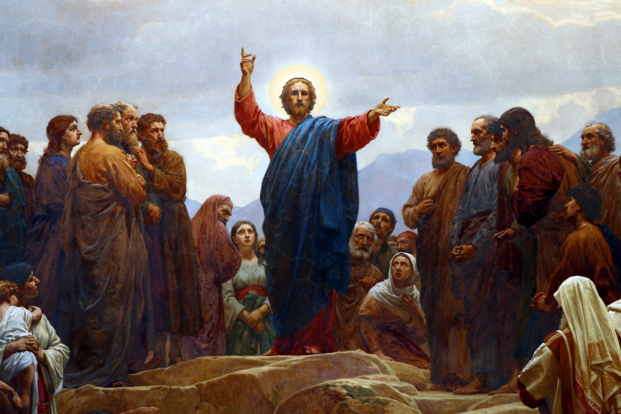

*Beware of the scribes... they will receive the greater*

*condemnation. Mark 12.38*

Jesus often warned his disciples against the wrong kind of

religion. In his denunciation of the scribes (the religious

experts of his day), he warns against three things: the

desire for prominence rather than selfless service; the desire for deference and recognition (and seeking esteem from others) rather than seeking to promote the good of others through humble service and love; and thirdly, attempting to use one's position (even a religious position) for self-gain and self-advancement. True religion is relating rightly to God and to one's neighbour with love, honour, and respect.

**OUR INTENTIONS TODAY.**Those in need: Tony Allen, Sarah Alderson, Jean Chapman, Peter George, Herbert Hinton, Maurice Houghton, Grace John, Heather Kinch, Kate Morl, Viv Rimmer, Diana Sanni, Elizabeth Sayer, Sheena Sixsmith, Margaret Summers, Sister Theresa at Walsingham, Fr Christopher Walker, Ann Westgarth and Nesta Williams.

The departed: Gladys Brant, Caroline Butler, Albert Butwell, Thomas Christopher, Walter Fishlock, Ruby Howman, Alexandra Marr, Elizabeth Provins and Ruth Weaver.

**OUR INTENTIONS TODAY.**Those in need: Tony Allen, Sarah Alderson, Jean Chapman, Peter George, Herbert Hinton, Maurice Houghton, Grace John, Heather Kinch, Kate Morl, Viv Rimmer, Diana Sanni, Elizabeth Sayer, Sheena Sixsmith, Margaret Summers, Sister Theresa at Walsingham, Fr Christopher Walker, Ann Westgarth and Nesta Williams.

The departed: Gladys Brant, Caroline Butler, Albert Butwell, Thomas Christopher, Walter Fishlock, Ruby Howman, Alexandra Marr, Elizabeth Provins and Ruth Weaver.

**Psalter Week 4**

**Sunday Readings: Year B. Weekday Readings: Year 1.**

**TODAY AT**

**S GILES**

Monday

09 November

Tuesday

10 November

Wednesday

11 November

Thursday

12 November

Friday

13 November

Saturday

14 November

**Sunday**

**15 November**

**Thirty-Second Sunday in Ordinary Time**

**(Remembrance Sunday)**

**10.00 Mattins**

**10.30 Parish Mass & Sunday School**

**17.30 Evensong**

**18.00 Low Mass**

Dedication of the Lateran Basilica

No Services

S Leo the Great, Priest, Doctor

09.00 Mattins

17.30 Evensong

18.00 Low Mass

S Martin of Tours, Bishop

10.00 Mattins

10.30 Low Mass

18.00 Evensong

S Josaphat, Bishop, Martyr

09.00 Mattins

18.30 Evensong

19.00 Low Mass

Friday of Week 32 in Ordinary Time

11.00 Mattins

11.30 Bible Study

12.30 Low Mass

16.30 Evensong

Saturday of Week 32 in Ordinary Time

09.30 Mattins

10.00 Low Mass

16.30 Evensong

**Reading Martyrs**

**10.00 Mattins**

**10.30 Parish Mass & Sunday School**

**17.30 Evensong**

**18.00 Low Mass**

**NOTICES & EVENTS**

*We welcome any visitors here this morning and hope that you will stay for refreshments after the service.*

**Bed for a Night volunteers needed!**Once again this year we will be helping with sheltering the homeless in Reading during the coldest period of winter.   If you are able to help one night a week with food and other assistance, please talk to the clergy.

Believe it or not, its time to start thinking about our **Christmas Shoeboxes**!   Information is available in the side aisle.  Please talk to Maddie Harris for more details.

**This Thursday** we begin having a low mass at 7pm in the Evenings.  All Welcome!

**The Next Sinners and Saints lecture** will be Fr Mark Laynesmith (Chaplain to the Univ. of Reading) on **Thursday 26 November at 7.30pm**.  He will be discussing the great Celtic saint, Alban, the first recorded English martyr.

*If you have any notices that require adding to the sheet, please contact Anne or Geoff Canterbury at canterbury@ntlworld.com or 0118 961 0525 by Wednesday of the previous week.*

**Sunday 8th November 2015 Thirty-Second Sunday in Ordinary Time**

**(Remembrance Sunday)**

**ENTRANCE ANTIPHON**

***Let my prayer come into your presence. Incline your ear to my cry for help, O Lord.***

**COLLECT**

Almighty and merciful God, graciously keep from us all adversity, so that, unhindered in mind and body alike, we may pursue in freedom of heart the things that are yours. Through our Lord Jesus Christ, your Son, who lives and reigns with you in the unity of the Holy Spirit, one God, for ever and ever.

***Amen.***

**THE FIRST READING** (1 Kings 17: 10-16)

*A reading from the first book of the Kings.*

Elijah the Prophet went off to Sidon. And when he reached the city gate, there was a widow gathering sticks; addressing her he said, "Please bring a little water in a vessel for me to drink." She was setting off to bring it when he called after her. "Please", he said, "bring me a scrap of bread in your hand." "As the Lord your

God lives," she replied, "I have no baked bread, but only a handful of meal in a jar and a little oil in a jug; I am just gathering a stick or two to go and prepare this for myself and my son to eat, and then we shall die." But Elijah said to her, "Do not be afraid, go and do as you have said; but first make a little scone of it for me and bring it to me, and then make some for yourself and for your son. For thus the Lord speaks, the God of Israel: 'Jar of meal shall not be spent, jug of oil shall not be emptied, before the day when the Lord sends rain on the face of the earth."

The woman went and did as Elijah told her and they ate the food, she, himself and her son. The jar of meal was not spent nor the jug of oil emptied, just as the Lord had foretold through Elijah.

*The Word of the Lord*

**THE GRADUAL PSALM** Psalm 145

**Response:** ***My soul, give praise to the Lord.***

***or***

***Alleluia!***

It is the Lord who keeps faith for ever, who is just to those who are oppressed.

It is he who gives bread to the hungry, the Lord, who sets prisoners free.

It is the Lord who gives sight to the blind, who raises up those who are bowed down.

It is the Lord who loves the just, the Lord, who protects the stranger.

The Lord upholds the widow and orphan but thwarts the path of the wicked.

The Lord will reign for ever, Zion's God, from age to age.

**THE SECOND LESSON** (Hebrews 9: 24-28)

*A reading from the letter to the Hebrews.*

It is not as though Christ had entered a man-made sanctuary which was only modelled on the real one; but it was heaven itself, so that he could appear in the actual presence of God on our behalf. And he does not have to offer himself again and again, like the high priest going into the sanctuary year after year with the blood that is not his own, or else he would have had to suffer over and over again since the world began. Instead of that, he has made his appearance once and for all, now at the end of the last age, to do away with sin by sacrificing himself. Since men only die once, and after that comes judgement, so Christ, too, offers

himself only once to take the faults of many on himself, and when he appears a second time, it will not be to deal with sin but to reward with salvation those who are waiting for him.

*The word of the Lord.*

**THE GOSPEL ACCLAMATION**

***Alleluia, alleluia!***

***Even if you have to die, says the Lord, keep faithful, and I will give you***

***the crown of life.***

***Alleluia!***

***or***

***Alleluia, alleluia!***

***How happy are the poor in spirit; theirs is the kingdom of heaven.***

***Alleluia!***

**THE HOLY GOSPEL** (Mark 12: 38-44)

*A reading from the holy Gospel according to Mark.*

(For shorter form read between > < )

In his teaching Jesus said, "Beware of the scribes who like to walk about in long robes, to be greeted obsequiously in the market squares, to take the front seats in the synagogues and the places of honour at banquets; these are the men who swallow the property of widows, while making a show of lengthy prayers. The

more severe will be the sentence they receive."

> He sat down opposite the treasury and watched the people putting money into the treasury, and many of the rich put in a great deal. A poor widow came and put in two small coins, the equivalent of a penny. Then he called his disciples and said to them, "I tell you solemnly, this poor widow has put more in than all who have contributed to the treasury; for they have all put in money they had over, but she from the little she had has put in everything she possessed, all she had to live on." <

*The Gospel of the Lord.*

**PRAYER OVER THE OFFERINGS**

Look with favour, we pray, O Lord, upon the sacrificial gifts offered here, that, celebrating in mystery the Passion of your Son, we may honour it with loving devotion. Through Christ our Lord.

***Amen.***

**COMMUNION ANTIPHON**

***The Lord is my shepherd; there is nothing I shall want. Fresh and green are the pastures where he gives me repose, near restful waters he leads me.***

***or***

***The disciples recognised the Lord Jesus in the breaking of bread.***

**PRAYER AFTER COMMUNION**  
Nourished by this sacred gift, O Lord, we give you thanks and beseech your mercy, that, by the pouring forth of your Spirit, the grace of integrity may endure in those your heavenly power has entered. Through Christ our Lord.

***Amen.***