S GILES-IN-READING

*Rector & Vicar:* Fr David Harris (0118) 9572831

*Curate:* Fr Sam McNally-Cross: (0118) 3767583

[*sgiles.vicar@gmail.com*](mailto:sgiles.vicar@gmail.com) [*sgiles.curate@gmail.com*](mailto:sgiles.curate@gmail.com)

*Churchwardens:* Sylvia Gooding & Peter Bloomfield

*sgilesreading.org.uk*

**Sunday 4th January 2015**

**The Epiphany of the Lord**

Hymns: ***The English Hymnal***

Mass Setting: *Gregory Murray*

Motet:

Entrance Hymn: *39*  Offertory Hymn: *42*

Communion Hymns: *40 & 597* Recessional: *41*

Voluntary: *Noel Suisse – D’Aquin*

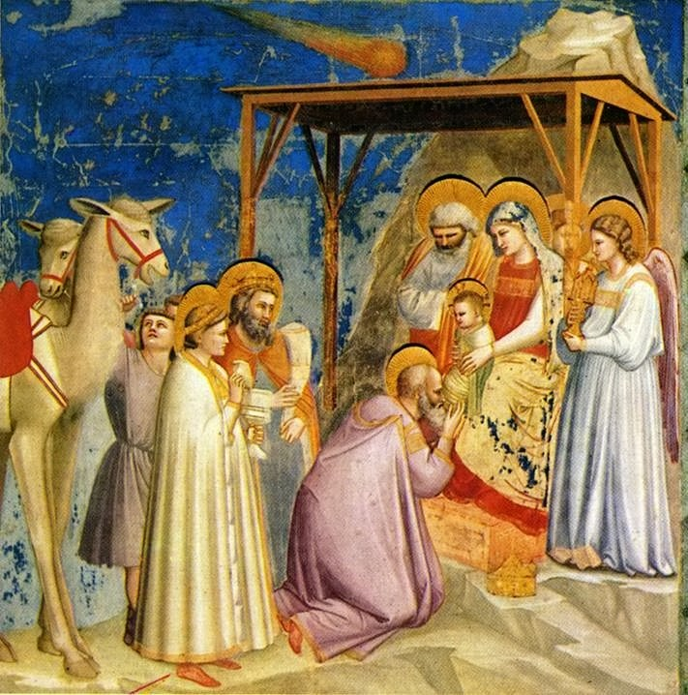

**OUR INTENTIONS TODAY.**Those in need: Tony Allen, Sarah Alderson, Jean Chapman, Peter George, Herbert Hinton, Maurice Houghton, Grace John, Heather Kinch, Kate Morl, Viv Rimmer, Diana Sanni, Elizabeth Sayer, Sheena Sixsmith, Margaret Summers, Sister Theresa at Walsingham, Fr Christopher Walker, Ann Westgarth and Nesta Williams.

The departed: Gladys Brant, Caroline Butler, Albert Butwell, Thomas Christopher, Walter Fishlock, Ruby Howman, Alexandra Marr, Elizabeth Provins and Ruth Weaver.

**OUR INTENTIONS TODAY.**Those in need: Tony Allen, Sarah Alderson, Jean Chapman, Peter George, Herbert Hinton, Maurice Houghton, Grace John, Heather Kinch, Kate Morl, Viv Rimmer, Diana Sanni, Elizabeth Sayer, Sheena Sixsmith, Margaret Summers, Sister Theresa at Walsingham, Fr Christopher Walker, Ann Westgarth and Nesta Williams.

The departed: Gladys Brant, Caroline Butler, Albert Butwell, Thomas Christopher, Walter Fishlock, Ruby Howman, Alexandra Marr, Elizabeth Provins and Ruth Weaver.

**OUR INTENTIONS TODAY.**Those in need: Tony Allen, Sarah Alderson, Jean Chapman, Peter George, Herbert Hinton, Maurice Houghton, Grace John, Heather Kinch, Kate Morl, Christopher Mott, Viv Rimmer, Diana Sanni, Elizabeth Sayer, Sheena Sixsmith, Margaret Summers, Sister Theresa at Walsingham, Fr Christopher Walker, Ann Westgarth and Nesta Williams.

The departed: Alice Coggs, Clara Higgs, Ernest Jermey, Harry Lusty, Charles Piggott, Albert Prater and Thomas Ruffell.

**Psalter Week 2**

**Sunday Readings: Year B. Weekday Readings: Year 1.**

**TODAY AT**

**S GILES**

Monday

05 January

Tuesday

06 January

Wednesday

07 January

Thursday

08 January

Friday

09 January

Saturday

10 January

**Sunday**

**11 January**

**The Epihany of the Lord**

**10.00 Mattins**

**10.30 Parish Mass & Sunday School**

**17.30 Evensong**

**18.00 Low Mass**

Monday after Epiphany

No Services

Tuesday after Epiphany

09.00 Mattins

17.30 Evensong

18.00 Low Mass

Wednesday after Epiphany

10.00 Mattins

10.30 Low Mass

18.00 Evensong

Thursday after Epiphany

11.30 Mattins

12.00 Low Mass

16.30 Evensong

Friday after Epiphany

12.00 Mattins

12.30 Low Mass

16.30 Evensong

Saturday after Epiphany

09.30 Mattins

10.00 Low Mass

16.30 Evensong

**The Baptism of the Lord**

**10.00 Mattins**

**10.30 Parish Mass & Sunday School**

**17.30 Evensong**

**18.00 Low Mass**

**NOTICES & EVENTS**

*We welcome any visitors here this morning and hope that you will stay for refreshments after the service.*

There will not be any Bible Study on Fridays until Friday 16 January 2015.

If you would like to join our Parish Pilgrimage to Walsingham on Friday 17 April 2015 to Sunday 2015 please see Brenda Alderson. Deadline for names is Sunday 11 January 2015.

*If you have any notices that require adding to the sheet, please contact Anne or Geoff Canterbury at canterbury@ntlworld.com or 0118 961 0525 by Wednesday of the previous week.*

Sunday 4th January 2015 – The Epiphany of the Lord.

**ENTRANCE ANTIPHON**

***Behold, the Lord, the Mighty One, has come; and kingship is in his grasp, and power and dominion.***

**COLLECT**

O God, who on this day revealed your Only Begotten Son to the nations by the guidance of a star, grant in your mercy that we, who know you already by faith, may be brought to behold the beauty of your sublime glory. Through our Lord Jesus Christ, your Son, who lives and reigns with you in the unity of the Holy Spirit, one God, for ever and ever.

***Amen.***

**THE FIRST LESSON** (Isaiah 60: 1-6)

*A reading from the prophet Isaiah.*

Arise, shine out Jerusalem, for your light has come, the glory of the Lord is rising on you, though night still covers the earth and darkness the peoples. Above you the Lord now rises and above you his glory appears. The nations come to your light and kings to your dawning brightness. Lift up your eyes and look round: all are assembling and coming towards you, your sons from far away and daughters being tenderly carried, At this sight you will grow radiant, your heart throbbing and full; since the riches of the sea will flow to you, the wealth of the nations come to you; camels in throngs will cover you, and dromedaries of Midian and Ephah; everyone in Sheba will come,

bringing gold and incense and singing the praise of the Lord.

*The Word of the Lord*

**THE GRADUAL PSALM** Psalm: 71

***R/ All nations shall fall prostrate before you, O Lord.***

O God, give your judgement to the king, to a king's son your justice,

that he may judge your people in justice and your poor in right judgement.

In his days justice shall flourish and peace till the moon fails.

He shall rule from sea to sea, from the Great River to earth's bounds.

The kings of Tarshish and the sea coasts shall pay him tribute.

The kings of Sheba and Seba shall bring him gifts.

Before him all kings shall fall prostrate, all nations shall serve him.

For he shall save the poor when they cry and the needy who are helpless.

He will have pity on the weak and save the lives of the poor.

**THE SECOND LESSON** (Ephesians 3: 2-3; 5-6)

*A reading from the letter of St Paul to the Ephesians.*

You have probably heard how I have been entrusted by God with the grace he meant for you, and that it was by a revelation that I was given the knowledge of the mystery. This mystery that has now been revealed through the Spirit to his holy apostles and prophets was unknown to any men in past generations; it means that pagans now share the same inheritance, that they are parts of the same body, and that the same promise has been made to them, in Christ Jesus, through the gospel.

*The Word of the Lord*

**THE GOSPEL ACCLAMATION**

***Alleluia, alleluia!***

***We saw his star as it rose and have come to do the Lord homage.***

***Alleluia!***

**THE HOLY GOSPEL** (Matthew 2: 1-12)

*A reading from the holy Gospel according to Matthew.*

After Jesus had been born at Bethlehem in Judaea during the reign of King Herod, some wise men came to Jerusalem from the east. "Where is the infant king of the Jews?" they asked. "We saw his star as it rose and have come to do him homage." When King Herod heard this he was perturbed, and so was the whole of Jerusalem. He called together all the chief priests and the scribes of the people, and enquired of them where the Christ was to be born, "At Bethlehem in Judaea," they told him "for this is what the prophet wrote: And you, Bethlehem, in the land of Judah, you are by no means least among the leaders of Judah, for out of you will come a leader who will shepherd my people Israel." Then Herod summoned the wise men to see him privately. He asked them the exact date on which the star had appeared, and sent them on to Bethlehem. "Go and find out all about the child," he said "and when you have found him, let me know, so that I too may go and do him homage." Having listened to what the king had to say, they set out. And there in front of them was the star they had seen rising; it went forward and halted over the place where the child was. The sight of the star filled them with delight,and going into the house they saw the child with his mother Mary,and falling to their knees they did him homage.

Then, opening their treasures, they offered him gifts of gold and frankincense and myrrh. But they were warned in a dream not to go back to Herod, and returned to their own country by a different way.

*The Gospel of the Lord.*

**PRAYER OVER THE OFFERINGS**

Look with favour, Lord, we pray, on these gifts of your Church, in which are offered now not gold or frankincense or myrrh, but he who by them is proclaimed, sacrificed and received, Jesus Christ. Who lives and reigns for ever and ever.

***Amen.***

**COMMUNION ANTIPHON**

***We have seen his star in the East, and have come with gifts to adore the Lord.***

**PRAYER AFTER COMMUNION**  
Go before us with heavenly light, O Lord, always and everywhere, that we may perceive with clear sight and revere with true affection the mystery in which you have willed us to participate. Through Christ our Lord.

***Amen.***